**Name:** *Nguyen Ngoc Anh*

**Country:** *Vietnam*

**Email:** *nguyenngocanh1092@gmail.com*

**“POLAND AND ME”**

“When I stayed, land it was,

When I left, part of my soul it became”

I am deeply impressed by those two sentences belonging to a poem by Che Lan Vien, a well-known Vietnamese poet. Indeed, leaving a place you once visited with many memories and breath-taking impressions, anyone would feel a mixture of indescribable feelings. Poland to me is such a place.

Since I was a little girl, I once dreamed of travelling to many countries that I’d never been to before. Not until 5 years ago, after finishing my Master Degree in England, did I get the chance to visit Poland. Europe is full of so many wonderful places, Poland is still one of my first destinations to visit, though. Poland is the country close to my heart and mind for several reasons.

Firstly, when I was in primary school, I had been told by my mom about a film in 1971 named *“Polonaise of Oginsky”.* The film told the story of an 8-year-old boy during the Second World War who played violin very beautifully in the resistance against the Nazis. The rhythm of the violin was so touching and patriotic. It seemed to be the pride of the whole nation in the fight against enemies. The movie soundtrack *“Polonaise Oginsky – Farewell to the Homeland”* was particularly successful in leaving a deep impression on many Vietnamese people at that time. No matter how long it’s been, the story about a young boy who played a role in defending his country is always engraved in my heart.. Five years ago, I finally made my dream come true as it was the first time I set my foot on the Old Town of Warsaw to explore and understand more about the home country of the song *“Polonaise –Farewell to the Homeland”.*

Secondly, I finished my Master Degree in International Relations in 2015 and it was also the year marking the 70th anniversary of the end of WWII. Poland was one of the countries mostly devastated during WWII. Later on, this country was under the Soviet Union’s influence for nearly half a century from 1945-1990. The shadow of Stalin continued to loom large over the country after the war. However, with the collapse of the Soviet Union in the early 1990s, Poland embarked on a reform program to transform itself into one of the fastest-growing economies in the European Union over the past decades. After submitting my dissertation in 2015, I decided to take a journey back to the old days to learn more about the story of Poland during the war time. It was lucky for me to visit Poland in such occasion to know how strong and determined it was to rebuild the whole country in terms of economic, social and political aspects. From a country being totally in ruins after the Second World War, Poland has now become the 7th largest economy in the EU with GDP at USD 605 billion (2019).

Thirdly, the person I admire most in my life and I am inspired by is my grandfather. He was a brave and devoted man who spent his whole life fighting in the Vietnam War and sacrificing his youth for the independence and freedom of my country. For many years, my grandfather served in the Vietnam People’s Army as the brigadier general. When he was young, my grandfather once travelled to Poland for his training program and he took many photos there. After many years, I still keep my grandfather’s old photos which have been spotted and torn at the edges. He wrote many interesting stories and memories about Poland on the back of each photo which really captivated me, sparked my imagination about Poland and nurtured my love for this country. Since then, I have been really curious about the beauty of the Old Town in Warsaw, the White Eagle as the national symbol of Poland, Zapiekanka, Mermaid of Warsaw, etc. Time went by, I told to myself that if I had the chance to visit Poland one day, I would come to visit places where my grandfather had been there once.

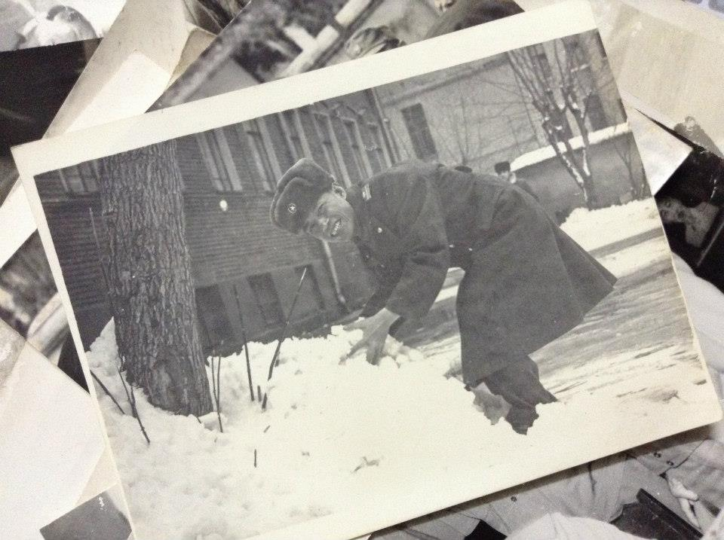

*My grandfather in Poland many years ago*

Fourthly, I am truly fascinated about Poland, its cultural and historical profile. This country is very famous as a source of some greatest minds in history including *Nicolaus Copernicus, Frederic Chopin, Marie Curie…* Many friends of mine wrongly believe those famous people were French. Therefore, whenever possible, I often tell to my friends that those famous people were actually Polish. They all have Polish roots and play a part in developing this beautiful nation.

I remember my first days in Warsaw as if they were yesterday. Within a short trip, I was exploring the Old Town, Royal Palace, Presidential Palace, the University of Warsaw, Lazienki Park, etc. I was truly amazed by the beauty of Warsaw and many fascinating mysteries such as the legendary Mermaid of Warsaw, the preserved heart of Frederic Chopin in the Holy Cross Church. I enjoyed wandering along the Vistula river, watching the vibrant life from the little cafes, relaxing and uncovering the hidden charm of the city during sunset. By visiting some historical museums there, I had the opportunity to learn more about the history of Jews in Poland. As I know, Poland was home to approximately 3.5 million Jews which used to be the largest Jewish community in Europe. However, the majority of them were killed by Nazis during the Holocaust.

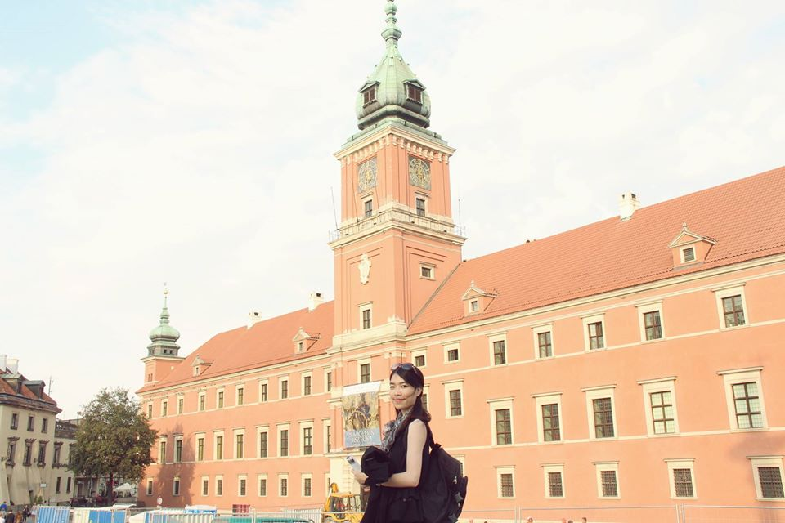

*I was in the Old Town, Warsaw 2015*

I have a feeling of great respect for the Polish wartime bravery, tolerance and heroism and for those who stood up against Nazism and fought for their freedom and national independence. My country and Poland shared many historical similarities. Our two countries used to be invaded and ruled by big powers. Hence, in the past, we both had to struggle to fight for the true meanings of independence and national sovereignty. We were so brave to keep fighting for freedom and never giving up. Even suffering from the dark history, Poland stands still and develops significantly to become such an emerging star in the world. I couldn’t believe in my eyes when I went to Warsaw to see how a devastated Poland with many building totally destroyed during WWII can rise up from the ash to achieve such high status as now. That is why I do love Poland and understand why Vietnamese people are so sympathetic for Polish people when Poland come to our minds. Even in Hanoi, my hometown, there is a high-school named “Vietnamese-Polish high school” built in 1960 to manifest the friendship between two nations. And the friendship between two countries is expected to further develop when nowadays there are more people interested in Polish language and culture.

Presently, I am working as the lecturer at the Faculty of International Studies, Hanoi University (HANU) in Vietnam. My University reintroduced Polish language to our students by launching the first language course last year, 2019. Polish language was officially introduced as the second language to our students. This is especially special in the course of strengthening bilateral relations between Vietnam and Poland. As the lecturer, I have the opportunity to inspire my students and spread the love for Poland and Polish language among my students. The students will be more interested in learning Polish and have many more working opportunities when nowadays more and more Polish companies choose Vietnam as an ideal investment destination.

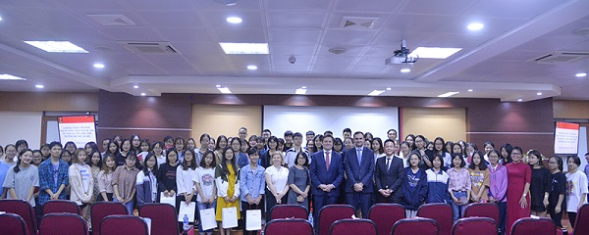

*Many HANU students are interested in Polish language*

My special impression about Polish people is that they are very nice, open-minded, supportive and extremely hard-working. Poland is known as a hard-working nation where people work very hard and effectively. In a conversation with my Polish friend, he said that he enjoyed working a lot and by hard work, he can reach his goals faster. I also realize that Polish people walk very fast in the streets and it seems that they think a lot about their work while walking with neutral face expression. However, when people started talking, they were very friendly and funny, especially when I as a foreigner tried to speak a little bit Polish language. Polish really loved that and they opened up then. Indeed, one of the best ways to discover and understand a country is through learning its language and vice versa. Therefore, it would be great if I have another chance to emerge myself in Polish culture to truly discover the rich history, language and culture of Poland.

As someone said *“each inch of Polish soil tells a story”,* visiting Poland was very touching and it was one of the most precious experiences that I will never forget. Suddenly, the poem “Em ơi Ba Lan” (My dear…Poland) from the famous Vietnamese poet To Huu is lingering in my mind. Poland has left deep and profound impressions on anyone who ever visited.

***“Em ơi, Ba Lan mùa tuyết tan  
Đường bạch dương sương trắng nắng tràn  
Anh đi, nghe tiếng người xưa ấy  
Ca ngàn năm….Ba Lan, Ba Lan”***

(My dear…Poland is in the thaw season

The roads of birch trees are now full of sunshine

I’m still walking, keep on walking

Singing for thousands of years…Poland, Poland)