The long journey to Poland
I have always wanted to travel to Poland. Why? Because my first memories of Poland started with my Grandfather, William Casimir Staniszewski. I never knew “Grandpa Bill” by this name until 2017 when I started planning a trip to Poland. As a child, Grandpa would occasionally tell stories about growing up in a large, Polish family in Milwaukee, Wisconsin. He told me about going to catholic school and church. I had also heard Grandpa’s mother’s parents came to the U.S. from Poland and his father came from Poland in the late-1890’s.
Grandpa came from a large family, he had nine siblings and was the third child born. Throughout his life, Grandpa was a hard-working family man who loved to go to his “train room” which was filled with his hobby of collecting railroad artifacts while he listened to his favorite music, Pavarotti, Chopin and Liberace. Although Grandpa was proud of being Polish, throughout most of his life being of Polish heritage was not popular and his family, like most immigrants to the U.S. wanted to be known as Americans. Unfortunately, the language and culture were casualties of pressure to be accepted in a new homeland. I think this may also be the reason why Grandpa did not share a lot about his family unless asked specific questions.
Grandpa did talk to me once with a gleam in his eyes as he mused about the incredible Polish wedding celebrations he had been to growing up in Milwaukee. I sat fascinated as he talked about “Polish Weddings.” Relatives came from near and far to celebrate with the soon-to-be married couple. The wedding rituals go on for several days with lots of food, dancing, singing and vodka. While listening to the story, I thought about how much fun it must have been to experience these multi-day events along with my new appreciation for the importance of marriage and family in the Polish culture.
Grandpa’s Polish roots popped up again, when he met my husband, also named Bill. The two men talked about going to Catholic school and being an altar boy in the church. Grandpa spoke a few words which sounded like Latin to me. Both Bill and I looked puzzled when we heard these new sounds. Grandpa spoke more words in Polish which is when Bill said, “I think he is speaking Polish.” This was the first time I had heard Grandpa speak Polish. I was shocked and amazed to learn Grandpa spoke Polish. I tried to repeat a couple of words but felt embarrassed because the sounds where so different. In the back of my mind, I thought about how impressed Grandpa would be if I could converse with him in Polish.
Throughout the years, I thought about going to Poland and learning to speak Polish. Bill wanted to go as did my Dad and his sister, Aunt Marlene. After talking about going to Poland so many times, I realized I had a developed a fond and deep connection to Grandpa’s heritage. I was hopeful someday; my family could make the journey together to see where our relatives lived and experience the beauty of Poland.
In 2017, my dream to go to Poland was finally becoming a reality. My aunt (Marlene) and I made the commitment to go to Poland in early 2018. We spent a lot of time talking about Grandpa and things he had told us about his family. We both wanted to experience the Polish culture and were giddy with excitement about our trip. Going to Poland was a life-long dream for both of us and spurred lots of conversations about Grandpa. We did not know much about his Polish roots but saw this trip as an opportunity to make up for the things we wish we could have known growing up.
I am a firm believer about things happening for a reason. One day, I was in a local store when I heard a woman who had a heavy accent. I was not exactly sure if it was Polish but became certain once I saw here holding a piece of Polish pottery. I introduced myself to Anna Wilewski, who probably thought at the time it was a bit strange for me to seek her out. Anna told me about being from Warsaw and I told her about the upcoming trip. I told her I had never been to Poland and would like her advice as a native on what to do. Anna and I talked for about fifteen minutes and then agreed it would be best to continue our conversation over the phone. I was so elated about the chance encounter with the person who is now one of my very good friends.
Over the next few weeks, Anna and I met in person to discuss the trip. She did internet research on how to find the local churches which may have records of my ancestors. Anna even emailed and called the local priests because since she spoke Polish, she could get answers much faster than a non-Polish speaker. She found the church in Cieklin along with the local priest who was in the process of digitizing the birth, death and marriage records for the village. Armed with this new knowledge, we included a trip to Cieklin on our itinerary along with hiring a polish, speaking guide who would take us there from Krakow.
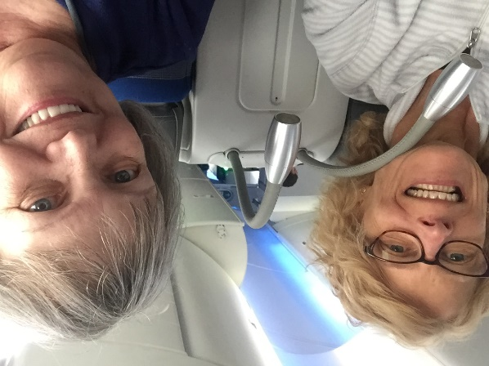
April 2, 2018, the day has finally come! Marlene and I boarded a LOT airlines flight from Chicago to Warsaw. We were both so excited to be experiencing our life-long dream. I remember how inspiring it was to hear the Polish-speaking flight crew. On the long flight, we talked about our joy of making the trip while sipping our first taste of Polish cherry vodka.
In each city we visited, we had formal tours planned but we also left ourselves flexibility to relax and get recommendations from locals on where to visit.

On our way to Warsaw!
In Warsaw we had a wonderful time on our tours of the Old Town area including the King’s Palace, Marie Curie Museum, the shrine with Chopin’s heart and Marie Curie museum. Our tour guide Marta spoke perfect English to us but my one regret was not being able to have a conversation with her in Polish. Although Marta was a native speaker, we also met and were inspired by Williams who was our driver to Lazienki Park. Williams came from Ethiopia two years earlier, had not spoken any Polish before but was clearly able to speak and understand his newly acquired tongue. I thought if he can do it, why can’t I?
Our next destination was Krakow where we would be based for the rest of our stay in Poland. Our excursion to Krakow was via train. It was a relaxing way for us to see the countryside. As I looked out the window, I was thinking about my Grandpa and how he would have enjoyed being on our trip with us. Krakow was an incredible city and both Marlene and I immediately fell in love with the beauty and culture. It was a place we could see ourselves living in and definitely visiting again.
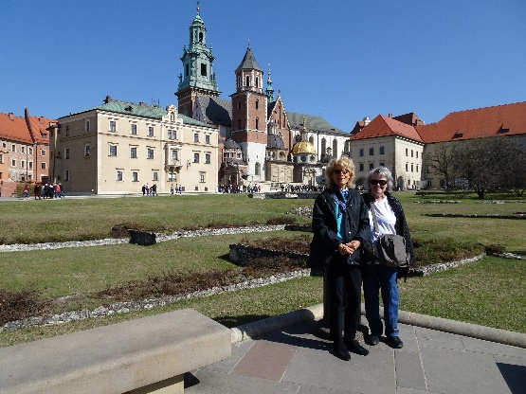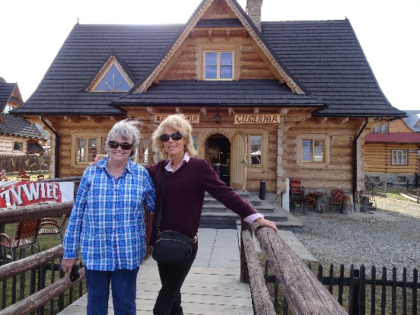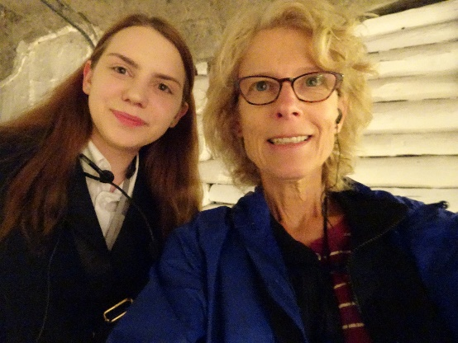
On the grounds of Wawel Castle Zakopane My Salt Mine tour guide, Ania
During our stay in Krakow, we went on daily walks through the parks around Jagiellonian University enjoying the spring flowers and warm weather. We ventured to Zakopane, the Salt Mines and to the crown jewel of the trip Grandpa’s relative’s village, Cieklin. Another inspiration was Ania, my young tour guide who was doing her first English-speaking tour. She was a little nervous at first but by the time the tour was over she was confident and proud of her accomplishment. Ania reminded me of how it’s important to take a chance and not let your fears about learning a new language stand in your way.
Our last major tour was to Cieklin, a long drive from Krakow. Marlene and I were so excited about prospects of meeting our new relatives. We were so thankful to have our guide, Marta who is a native Polish speaker on the trip. Our visit to Cieklin is another whole essay, but going there also made me want to learn Polish even more as we met our distant cousins who mainly spoke Polish.
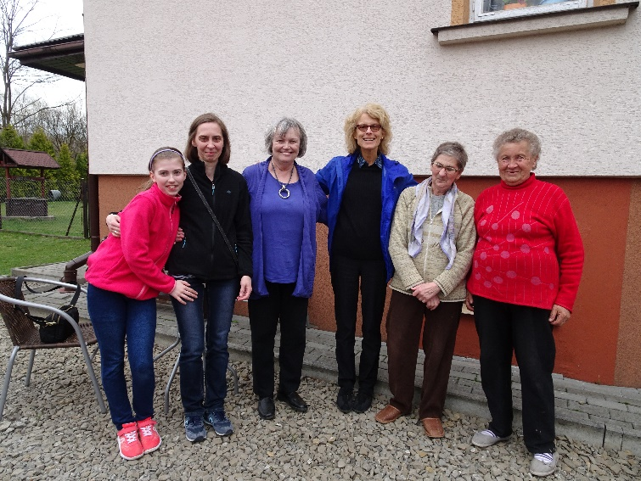O
Together at last – three generations of Staniszewska’s!
After returning from this incredible trip to Poland, I felt so happy about the journey and how I am looking forward to going back. I also decided it was time to learn Polish and found a local Polish School which offered adult Polish language classes. I was nervous and excited to be finally learning the language my Grandpa and all of the new friends I had we spoke Polish.
Over the last few months, learning Polish has not been easy, but for me it’s not a single experience of learning the language, it’s about the journey along the way with the blessings of new friends who enrich our lives. I have found this to be true about my Polish classes. Almost everyone in my class is married to a native Polish speaker, which can be intimidating for my beginner skills. However, all of my classmates are encouraging and giving praise of how much my pronunciation has improved. I am so thankful for these new friends including two great teachers who are helping me learn both grammar and speaking Polish.
Although it’s been almost a year since the trip, I smile every time when I think about my trip to Poland. I am longing to and will hopefully go back soon to learn and practice my Polish!

