24.12
Dear Diary!
People used to say that the grass is always greener on the other side of the fence. Do they have a point? Great Majority would say: „yes”, but our family cannot say it ourselves while having six wonderful children. Michael, Sabine, Brygide , Kris, Alex and I are representing the fantasy of eternal youth. We are the glorification of undying spirit of creativity. Nowadays, elderly people tend to identify the youngest offspring as being too lazy to create anything. You, my Diary, have listened how we break the stereotypes many, many times. Do you wanna listen again? Ok, I know that you are not alive and you are the one to listen to me whenever I need it. That is why I love you.

***

„Ann, come down at once”- shouted my mum stopping me putting on my make-up. I tried to make a polite request, but I did not succeed with saying: „Give me 5 minutes, please.” in a low- pitched voice. I should have known I am the looser when my mum has too much on her mind and is clearly at the end of her tether. Noticing her tattered nerves I threw away my mascara to run downstairs. Christmas supper was about to start, hence I calmed down my mother putting my palm on her arm.
„Ho, ho, ho! Are you ready to go?” - my father asked, he was dressed as Santa Claus who we were waiting for.
„Stop playing fool! The supper starts in ten minutes! We have not left our house yet!” - My mum was constantly getting into a lather.
„Sweetheart, your brother lives 20 m from here. We still have plenty of time.”
„You drive me up the wall.” - she replied, nevertheless a little grin appeared on her face. - „Ok, Ann, you take the borsch.”
„Sure mum.”
„Kris, you take that plate with fried carps.”
„Sorry mum, but..., well... I am carrying this plastic piano and...”
„Tree rolls of toilet paper on a wooden stick ?! Have you gone mad my son?! And... what are those sunglasses meant for?!”
„You will see not long after the supper”
„If you want to keep on good terms with me, live it at home.”
„Why on earth are you always pouring cold water on my ideas ?!”
„Because this night we are expecting Jesus’ birth. It is not a clown night.”
„You are quite right in my opinion. Of course it is not a clown night, nonetheless we should be cheerful. I promise, you will be on cloud nine when you see our play.”

***
Our seats have been arranged. There was a piece of paper on every plate with a name of a person (whose seat it was) and a photo of that person from their childhood.
The solemn evening meal begun with some prayers and wishes. We consumed all the mouth– watering dishes soon after and nothing has left. Oh , Diary if you could only understand how delicious it was! But it was nothing in comparison with unforgettable Christmas ambience in the room.

When we were done, all the children went upstairs to get ready for the show. It took us approximately ten minutes to organise things.

***
„Welcome, the winner of the previous edition of our TV show. It is just a sign of things to come...” - announced Michael.
Seven-year- old Brygide, with her soft blond hair up to hips, walked on the stage. She had a crown and a pair of sunglasses on. I turned the radio on to play Mariah Carey’s song. Playbacking „All I want for Christmas” was my sister’s task. She was holding a microphone in her left hand and she was gesticulating with the right one.
The funniest thing was that she could not playback at all, so she sang : „Bla, bla, blabla”.
After a while my little brother made a series of large leaps while hitting the stage. Not only was Kris treading, but he also was making the audience believe he played plastic piano so it caused an indescribable atmosphere. Our family was crying out of laugh.
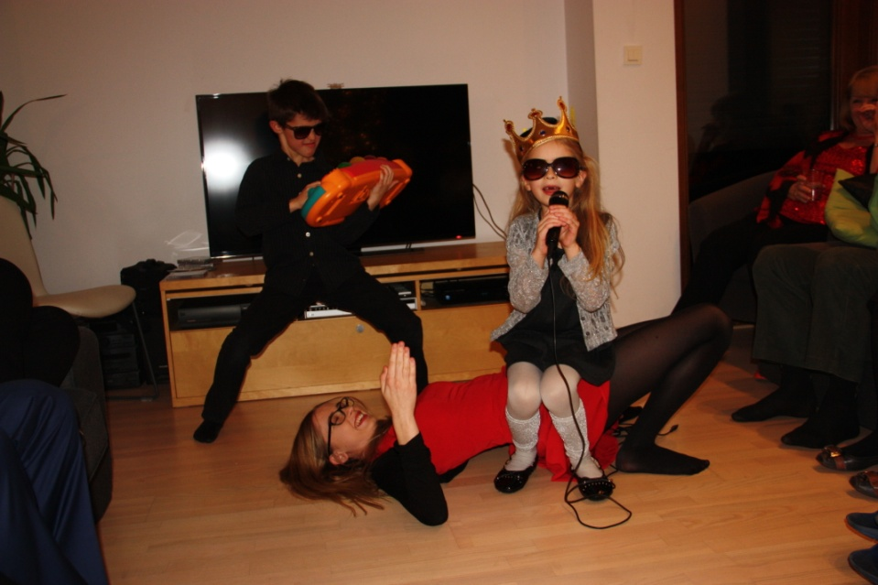

„Now you, participants of this edition, are going to dance. Stand up and dance!” - I asked them out of the blue. Our parents, grandparents and even ninety – two years old great – grand father, they all stood up. Soon they went wild and their dance – style became too wild to describe.
None of present adults noticed Sabine and Alex sitting back to them. Sabine’s and Alex’s armchairs brought to mind the ones from „The voice of Poland” .
When the dance came to an end Michael told what was going on.
„If our jury thinks you can participate in our programme, they will press the button „I want you””.
Sabine and Alex pressed the buttons and picked their teams.
„Georg” - said Sabine to our dad - „the sound of your step makes me think, you have participated in our programme since 1971. Welcome to my team!!! And you Bogdan were something between a cat, a coyote and a gerbil. You are stunning... you are simply wooooow!!!! You must be in my team!”
„Martin, you moves like a sexy kitty!!!! That is why I would like to offer you a warm welcome in my team!” - yeah, Alex gave a really polite speech (to our great – grand father). We do not talk like this every day, we respect our relatives, but sometimes we need to GO MAAAD. They need it as well.
However, the next point of our show was mostly dedicated to the most quick – witted pair. One person from Sabine’s team and one from Alex’s. The competition was called „a reporter”. Each of the two competitors was supposed to choose a word and use it in the conversation so that opponent team won’t figure out which word was it. Our mum got the word: „boomerang” while our granddad got: „to gut”. The topic of their talk, given by us, sounded: Christmas cuisine. After a minute – long conversation the opponent team was supposed to guess the hidden word. Despite being in a very difficult situation, our mother did a great job. She said that people in Japan were used to eating sushi on boomerangs and the second team did not guess it. First competition ended up with a score 0:0.
The second competition was meant rather for a pair of musicians. They were asked to sing a carol. However, the first word of the carol must have been sang by the first person, the second word by the second person, third word by the first person again and so on.
"Gossip" was how the next competition was called. Three of our older relatives were asked to live the room so that they wouldn’t hear the text. The text was read by my older brother – Mike. It's subject, carol creation, unknown for the present adults, had them in stitches. The text was ful of strange Latin words and dates. Who can memorise dates at once? In fact, we made it for fantabulous amusement. Their faces had shown us we did our job.
After all the competitions I announced that all the efforts put in our show were actually superfluous.
„In fact, we are moving to the lottery right now. Let's draw lots to decide who the winner is” - I added and laughter filled the room.
My cute sister appeared on the „stage” with a little transparent plastic box hanged on her neck. It was filled up with two types of tiny balls: yellow and white ones.
„Applause for our National Lottery machine.” - said Michael - „The drum is empty. Dismantle the blockade, please.”.
Brygide started pushing her chest to make the box jump.
„Stop!” - shouted Michael as the balls were about to come out. He opened the box and took one ball. - „I choose at random a yellow ball. Applause for that!.... Anyway, who likes pink?”
Our grandfather raised his hand.
„Congratulations, you are almost the winner!!!” - was how Michael described the grandfather’s actual status - „Now you need to play fruit machine. This stick with tree rolls of toilet paper on it is our slot machine. Each spinning reel has a diamond, a spade and a heart symbol painted on it. You are going to spin them all. If you stop the rolls and have free identical symbols in one row, you win the programme.”
Each member of my family giggled.

