DAY 1
I woke up in a completely different reality. It was sunny morning. I knew I was in another country, village and what is the most importantly in a foreign home. I was in UKRAINE! I have remembered that I am here, because I take part in voluntary work. I got up from my bed, I went to wash up and I sat down to breakfast. It was really delicious and I am really hungry. On the table was freshly baked bread, homely products and delicious, hot coffee. Breakfast took me about half an hour. Then I changed into in working clothes and I went on foot to the cemetery. During the way I saw a lot of people going to the church for morning mass! I knew that the Ukrainians this pious people, but that so it is not. Passing the church I was a little disgusted, because I wanted to him enter, but unfortunately I had no time. After a few minutes I found myself in the city center. There was around fifteen minutes walk to the cementary. Without waisting my time I quickly went towards him. At about ten o’clock I reached to objective. Along with a group of colleagues from school I have started sorting out polish graves. There were dirty and around them lush, overgrown with grass. However, after eight hours of worki t was already visible effects. The grass was cut and the tombs partially cleared. After finishing work about eight o’clock I came „home”. I got dinner after which I went sleep, because I wanted to relax. It took me two hours. Then I changed into clean clothes and I went out on the town. There I met with friend from the local town and I came „home”. I dressed pajams, I washed myself and I went sleep.

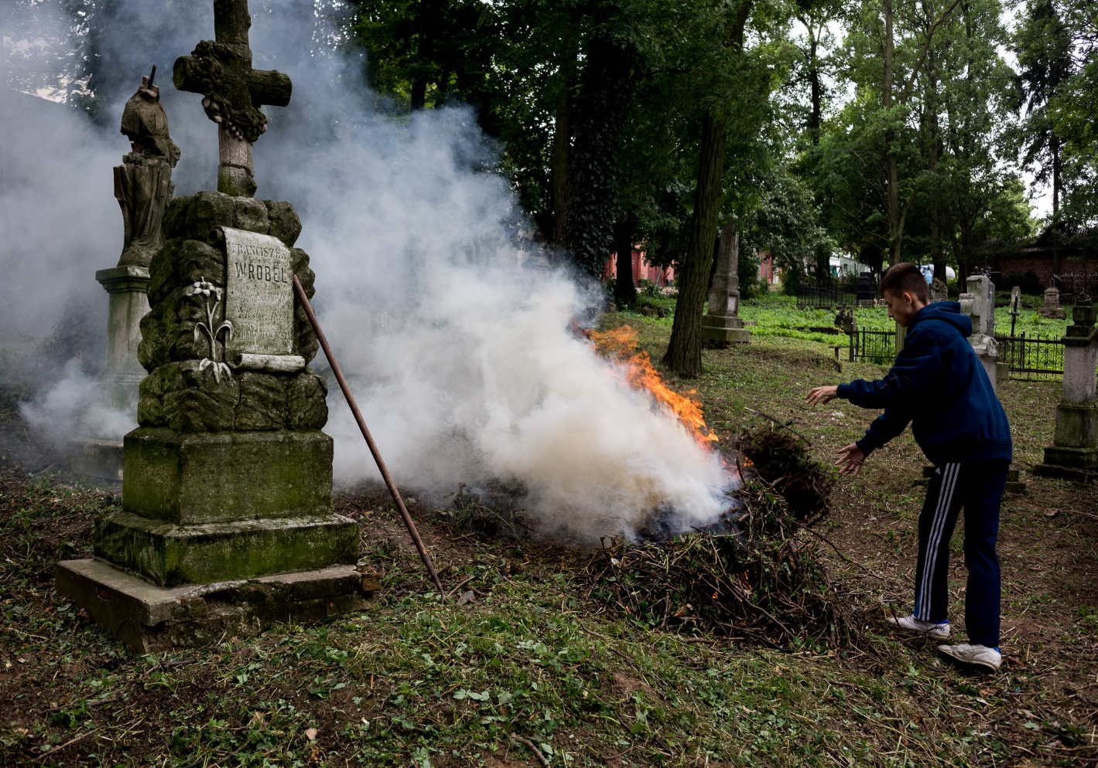

DAY 2
Next days in this place passed me by positive experience. However, recently I was little depressed, because I missed my nameland, family and girlfriend. I missed our Polish reality in this foreign country. At some moments, the tears came to my eyes at the memory of loved ones. But I knew that soon I get home and then I will eat delicious Polish dinner prepared by my mum and I will be able to hug all family. These thougnts comforted me. For now I had to get used to everything here it was different. This trip also had good sides, which kept me still here. Living with these people I was able to get to know the local culture and traditions, visit the beautiful places, learn the basics of the language and make new friends. I started day at seven o’clock in the morning. The weather was brilliant. It was very hot and cloudless every day. I woke up from sleep by the singing of birds. I admit, it is nice twittered. However, I felt a little sad… this was before the penultimate day stay in Ukraine. I loved this country and I would like in the future to visit him. After eating breakfast with a group we went to the cemetery to finish what we had, and then for shopping and sightseeing in Lviv. This town was really beautiful! Stands, taverns, bars, dairy or underground restaurants, just feel it was the atmosphere! Globalization has gone into oblivion!!! In addition, I felt Polishness in this city „ sometime our - now foreign”. During the tour of Lviv in the memory stuck in my Lychakiv Cemetery. Cemetery of Defenders of Lviv, also called the Eaglets Cemetery, is one of those places where deep emotion overwhelmed everyone back and hold for a long time. It is the resting place of all those young Poles who grabbed the gun, killed in defense of what they had most valuable - your own home, which was a Polish Lvov. After the cemetery we went to the station Lviv. It was really beautiful and very large. Ukrainian Railways is completely different from Poland. Different size tracks, and is also more extensive. We also toured the beautiful tall castle, where at the top there was a vantage point - say otherwise panorama of Lviv. It was really something! Strolling through the streets of this old but charming city I decided to try the local dishes. I visited the restaurant, where the dumplings were served and very tasty Ukrainian borscht. When I was sitting in this very restaurant and watched as the borscht is done, my attention turned beautiful fountain in the market. Anyone who threw a coin lucky for further years of life. Well, I must admit that as I did. I forgot to mention that being in the city I decided to take a ride in a taxi. It cost without thinking. I go tinto a taxi with my friend and we gave a sensational driving in this wonderfull city. Wonestly speaking, I knew that the drive would be so crazy. Our driver was in a hurry in the Lviv if it were highway, talking in me meantime in Polish. WOW! It suprisea us! But he wasn’t suprised, because he knew that we are from Poland, that is why he spoke Polish. It was beautiful final of one of the last in this amazing country. At seventeen o’clock we returned to the town, where we were staying. Everyone went to his home to prepare for unwanted trip. I was really sad because of this… . I really liked these people, because they were simple people but having the heart and open to others. When I needed any help during my week stay I was getting to her - whether they knew me or not.
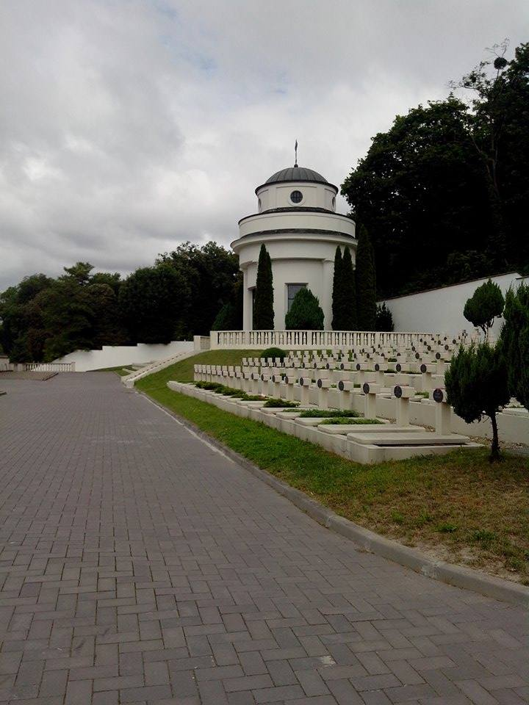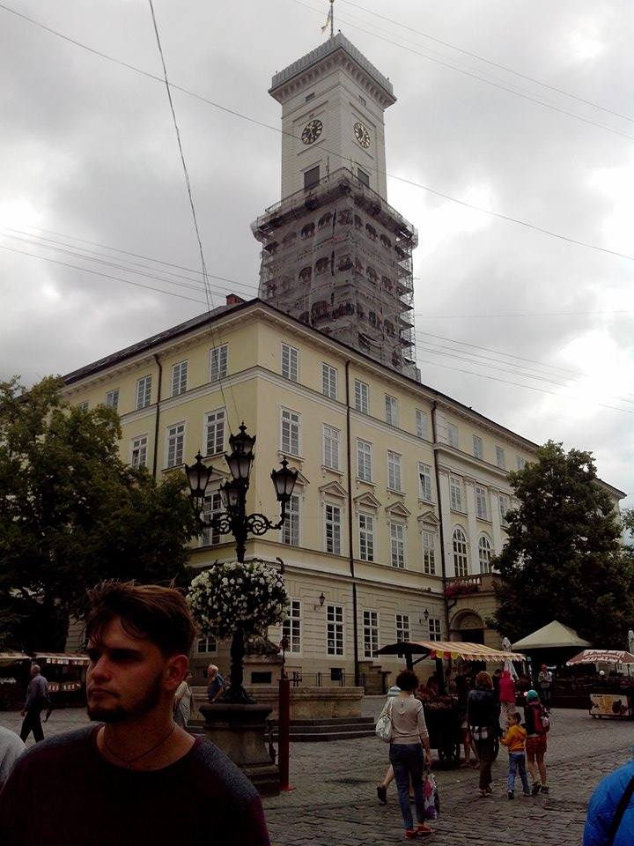
DAY 3
Day of departure has come on! I was got up in the morning flew me tear of all this! I was sad that I had to leave these people who give so much another human although they do not have a lot. The market town was waiting for us bus. He was waiting at twelve o’clock however, just we set off on a journey at the sixteenth o’clock. It is influenced by the situation, which took place on the border. A lot of people came to say goodbye to our. They fell good words, handshakes and even sweets! Thanked for it that we remember those people who have lived here! I thought to myself, why do I like this country… I was quickly found the answer. Ukraine like for it is a beautiful country and the people who live there have their value. In addition, all are helpful for you! There is so like us that one offends second - is simply different! I told myself then that is what they say on television about patriotism is total untruth. I understand it completely differently. Patriotism can be called the memory of the heroes, the people who were Poles, and the state of them forgot. I was happy that I could come here and put to order the graves of my ancestors, who they deserved to mind, not to be forgotten! On the last day of our holidays we bought some souvenirs for our friends and family form Poland . I had a very good time in Ukraine and I would like to have more holidays like this one. I believe that I will return there!

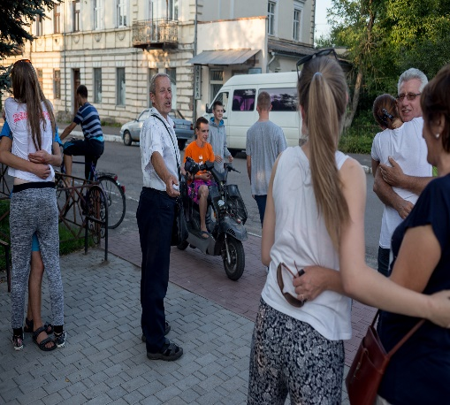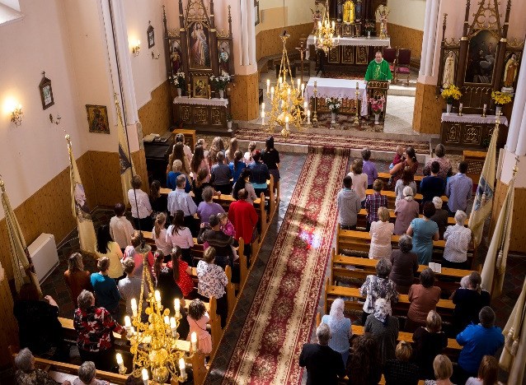

DAY 4
Already I drove up to the border. As is well known in the east the time is ahead by one. At the border there was no longer a riot, but the silence. We were on it at four in the morning and waited about half an hour for it, until he comes to our turn exceeded. When it came time already, everyone gasped. Everyone is afraid, but there was nothing, because we did not have anything illegal in the transportation process. Once you have crossed the border, we found ourselves in a completely different reality. It was Poland - my dear homeland. Polish subtitles, Poland speech - everything was understandable although I admit that remained yearning for the beautiful, green Ukraine, with which you can sing in the song "Hej Sokoły". Moreover, I think that the memory of compatriots is an important thing!

THANK YOU VERY MUCH!
